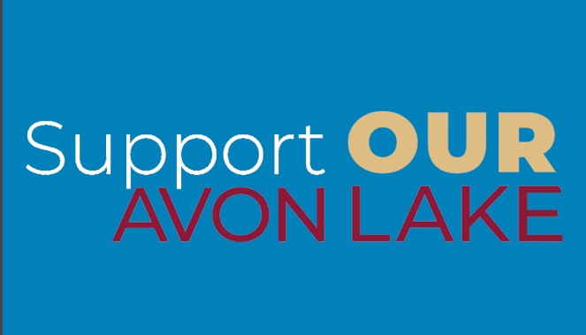

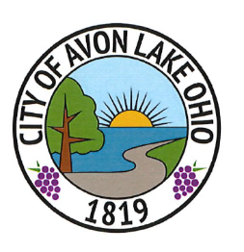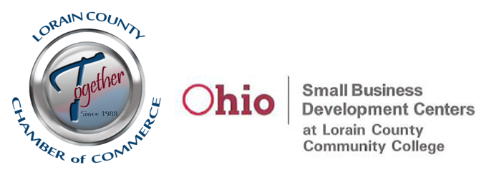

2021 Small Business COVID-19 Relief Grant

Program Guide

November 2021

2021 Small Business COVID-19 Relief Grant
PROGRAM GUIDELINES
The 2021 Small Business COVID-19 Relief Grant (the “Program”) is a small business grant program that has been created by the City of Avon Lake (the “City”) in order to assist small businesses in Avon Lake with the financial hardship imposed by the COVID-19 pandemic over the last two years. The Lorain County Chamber of Commerce (the “Chamber”) will play an administrative and organizational role in this program, and they will receive support from the Ohio Small Business Development Center (SBDC) located at Lorain County Community College. The below guidelines establish the businesses eligible for funding, the type of business expenses that can be paid with grant funds, and the application and award process.
- General Description of the Program

Eligible businesses will be able to receive grant funds from the program in order to assist with operating expenses incurred during 2021. Generally, the amount of the grant per business will range from $1,000 to a maximum of $2,500. The amount of each grant award will be determined by the applicant’s demonstration of need and hardship, as well as the clarity of their request (including quality of supporting documents). In addition, during the administration of the program, the City may consider the amount of funding remaining in the program and/or number of applications submitted when determining the grant amount.

Applicants must submit an application (attached to these guidelines) to the Chamber, which will review the application for completeness and compliance with the guidelines. In reviewing the application materials, the Chamber will be in regular contact with the City to provide the status of each application. Applicants who meet the criteria set forth below will be awarded funding on a first come-first serve basis. Once approved, and upon proper receipt of all required documentation, the Chamber will issue payment, and the City will deliver payment to the business as soon as practical. All grant funds will be used solely for business-related expenses, as set forth below. All grants made under the Program are being made with the intention to provide immediate funding to small businesses to meet their business needs, to keep small businesses in Avon Lake operating, and to retain as many jobs as possible in light of the severe economic hardships brought by the COVID-19 pandemic.

- Eligibility Criteria

- To be eligible for grant funds under the Program, Avon Lake businesses must meet the following requirements:

  - The business may be a sole proprietorship, partnership, corporation (both S and C), professional association, limited liability company, limited partnership or limited liability partnership. If a corporation, professional association, limited liability company, limited partnership or limited liability partnership, the business must be registered with the Ohio Secretary of State to do business in the State of Ohio. If a sole proprietorship, the business shall provide documentation of its existence as a business, including, but not limited to income tax returns for the business, trade name registrations, business banking or credit accounts or such similar documents. If a partnership, the business shall either be registered with the Ohio Secretary of State to do business in the State of Ohio, or, if not registered, shall provide documentation similar to that required for a sole proprietorship.

  - The business must be privately held.

  - The principal place of business for the business must be located within the City of Avon Lake, and must be in a commercial building—home based businesses are not eligible
- The business can employ a maximum of twenty employees. For purposes of this criteria, “employees” shall mean individuals who regularly work at least 20 hours per week and who are (i) individuals who are employed as employees and provided an IRS Form W-2 at the end of each calendar year, or (ii) individuals who are independently contracted with the business and receive an IRS Form 1099 at the end of each calendar year, and who primarily or exclusively contract with only the business during the year. For purposes of determining whether the business employs the requisite number of individuals, the principal owners of the business do not need to be included in the number of employees if it would cause the business to exceed the maximum number of individuals employed.

- If the business has been operating in Avon Lake for less than one year as of the date of applying, that business must provide a copy of a mortgage, or a lease for at term of at least two years, in order to demonstrate that the business has made a financial and contractual commitment to their commercial space in Avon Lake.

- Regardless of its general eligibility above, the business shall NOT be a financial institution that makes loans or issues credit to the public, including, but not limited to, banks, credit unions, payday lenders, or any other similar business

- Eligible expenses

A. Unless excepted below, all expenses of the business that are deductible as ordinary and necessary business expenses under the U.S. Internal Revenue Code may be paid for with grant funds from the Program. Examples of eligible expenses include, but are not limited to:

- Salaries or wages of all employees employed by the business

- Mortgage payments for the business’s principal place of business in Avon Lake

- Rent payments for the business’s principal place of business or such other business location in Avon Lake

- Utility payments – electric, gas, sewer, water, trash removal – for the business’s principal place of business or such other business location in Avon Lake

- Health, property and casualty and liability insurance payments

- Lease or rental payments for vehicles or equipment that are part of the business operation

B. Each applicant for funds will include in its application to the Chamber an itemization of the expenses it intends to pay with the grant funds, which will be reviewed for compliance with the eligible expenses set forth above.

C. Following the expenditure of all grant funds, the business shall provide a listing to the Chamber of all business expenses paid using the grant funds along with supporting documentation. Documentation will be in the form of cancelled checks, paid invoices, bank statements or similar documents evidencing payment. The listing of business expenses paid and accompanying documentation shall be submitted to the Chamber no later than 180 days following the receipt of grant funds by the business. Grantees who do not provide these documents risk future funding from the City and the Chamber.
D. All expenses reported to the Chamber as paid using Program funds must either be incurred by the business or paid by the business within ninety (90) days of receipt of grant funds. No grant funds may be used to pay for vehicles or equipment leased or purchased after the date that the application was submitted.

- Application and Award Process

A. Businesses that wish to apply for a grant from the Program shall submit to the Chamber the following documents by email in electronic format:

- A completed application form, available on the Chamber’s website

- An itemization of the business’s ordinary and necessary monthly business expenses

- An itemization of all business expenses that the business will pay with grant funds awarded from the Program

B. Upon receipt of each application, the Chamber will examine it for completeness and ensure that all items required are included. In the event the application is incomplete and/or the applicant fails to include all information required above, then the Chamber will notify, by email, the applicant of the incomplete submission. The applicant may then provide additional necessary information to the Chamber.

C. Upon receipt of a complete application and all information required, above, the Chamber will give the application a sequential number indicating the order that the complete application was received.

D. On the day that grant funds are available, the Chamber will prepare the grant awards in order of sequential application number. Grants will be funded to as many applicants until the funding is exhausted. The grant award checks will then be given to the City for delivery to the grantees.
E. While the maximum grant amount under the Program is $2,500, the City may reduce the maximum grant amount in order to provide grants to more businesses, based on the pace of applications.

